The principle and method of immunoprecipitation (IP)

Immunoprecipitation (IP) is a method to isolate a specific antigen from a mixture, using the antigen-antibody interaction. Antigens isolated by IP are analyzed by SDS-PAGE or Western blotting.

The principle
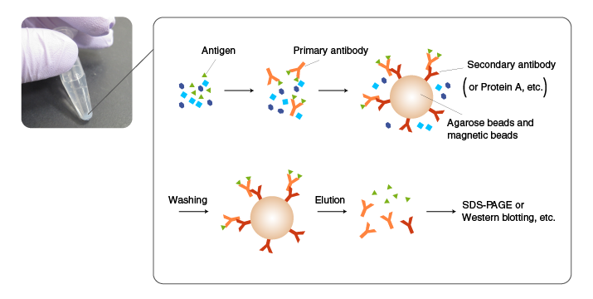
In IP, an antibody is added first to a mixture containing an antigen, and incubated to allow antigen-antibody complexes to form.
Subsequently, the antigen-antibody complexes are incubated with an immobilized antibody against the primary antibody (secondary antibody) or with protein A/G-coated beads to allow them to absorb the complexes.
The beads are then thoroughly washed, and the antigen is eluted from the beads by an acidic solution or SDS.
If suitable antibody is not available, the target molecule is fused to a His tag or other tags by recombinant DNA techniques, and immunoprecipitated using an antibody to the tag (pull-down assay).
[Related topics] Pull-down assay experiments using Tagged protein purification kits

The use of an antibody with high binding specificity and affinity for the antigen is critical for successful IP.
Antibodies raised against synthetic peptides and recombinant proteins often work well in Western blotting but may not bind the antigens in their native conformation in solution.
When using commercial antibodies, select the ones that are suitable for IP according to product information. Also recognize the properties of both the antibody and antigen in the literature and product information.

Tips for efficient IP
The diagram on the right illustrates the structures of antigen-antibody complexes formed with a monoclonal versus polyclonal antibody as the primary antibody.
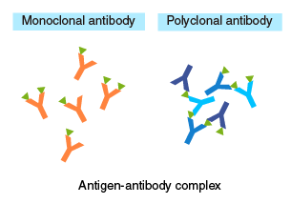
When using a monoclonal antibody as the primary antibody, adjust the concentration so that:
[secondary antibody] > [primary antibody] > [antigen].
An excess of primary antibody, relative to the secondary antibody, may compete with antigen-antibody complexes for the secondary antibody, resulting in a lower yield of recovery.
When using a polyclonal antibody, an excess of primary antibody, relative to the antigen, will prevent the formation of oligomeric complexes. Therefore, these concentrations should be optimized by testing different ratios.

Comparison of primary antibodies for IP
 | Monoclonal antibody | Polyclonal antibody
Background | Background is low with an appropriate antibody because the antibody recognizes a single antigen. | Background may be high if some of the antibody molecules have a low specificity and bind to proteins other than the target protein.
Binding affinity | High-affinity monoclonal antibody (dissociation constant K_{d}<10⁻⁸ M) should be used because low affinity antibody may not form an antigen-antibody complex in solution. | Even if the affinity of individual antibody molecules is low, oligomeric antigen-antibody complexes are formed easily due to the multivalent binding.
Stability of antigen-antibody complexes | If the binding affinity of an antibody is low, simultaneously using several high-specificity monoclonal antibodies will allow multivalent binding, resulting in stable antigen-antibody complexes. | Stable oligomeric complexes are formed because reaction between a polyclonal antibody and an antigen is multivalent.

Beads for immobilization
Agarose beads and magnetic beads are commonly used.
Agarose beads have a porous, mesh-like structure, and antibodies can diffuse and bind to the internal matrix of the beads, which provides high binding capacity.
Magnetic beads are simple spheres, providing ease of handling and short processing time. With appropriate coating, background can be reduced. However, binding capacity may not be high enough for some applications, and the cost is higher than the alternative using agarose beads.
Magnetic agarose beads provide ease of handling (when used with a magnet) and a high binding capacity.
Comparison of beads used for IP
 | Agarose beads | Magnetic beads | Magnetic agarose beads
Diameter (MBL products) | Approx. 100 µm | Approx. 1.6 µm | Approx. 50 µm
Diagram of the bead structure and antibody coat |  | 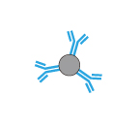 | 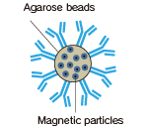
Actual images | 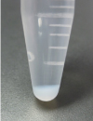 | 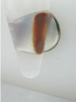 | 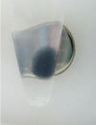
IgG binding capacity per matrix | High | Moderate | High
Likelihood of sample loss | Sample loss may occur during the washing step. | Sample loss is negligible because the beads are pelleted using a magnet. | Sample loss is minimal because the beads are pelleted using a magnet.
Centrifugation | Necessary | Unnecessary | Unnecessary
Magnetic rack | Unnecessary | Necessary | Necessary
Visibility of the beads | Poor | Excellent | Excellent
Other features | Inexpensive | Easy to disperse; useful for screening, etc. | Less expensive and provides a higher yield than magnetic beads.

[Related topics] Smart-IP tag-antibodies conjugated with magnetic beads or magnetic agarose

Detergents
Appropriate concentrations of salt and non-ionic detergent are commonly used in IP to reduce non-specific binding (protein-protein and protein-bead interactions). Pilot experiments should be performed with detergents, which may reduce the affinity of the antibody, especially when using a monoclonal antibody.

Protease inhibitors
The target protein and antibody are subject to degradation by protein-degrading enzymes (proteases) in samples such as cell lysates and tissue extracts. To prevent proteolytic degradation, protease inhibitors are included. When the type of proteases in samples are known or predicted, specific inhibitors are used. When proteases are unknown, a combination of multiple small molecule inhibitors, such as PMSF and EDTA, are used.

Elution condition
In most applications, proteins are eluted in SDS sample buffer containing a reducing agent, such as 2-mercaptoethanol(2-ME). In addition to the target protein, the antibodies used for IP are co-eluted, which should be considered when performing Western blotting or mass analysis.

Procedure
IP (with agarose beads) ※An example performed at MBL
Step-by-step procedure
Incubation with a primary antibody  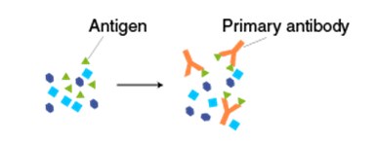  Add 500 µL of protein extract and 2-10 µg of the primary antibody to a 1.5-mL tube. | 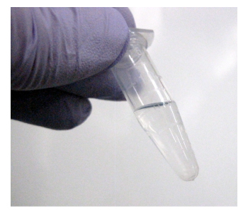
Incubate at 4°C for 1 hour-overnight with shaking on a rotator. | 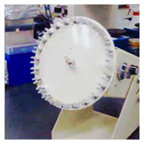
Incubation with a secondary antibody  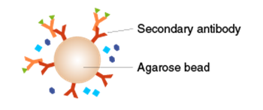  Add secondary antibody-coated (or protein A/G-coated) agarose beads. | 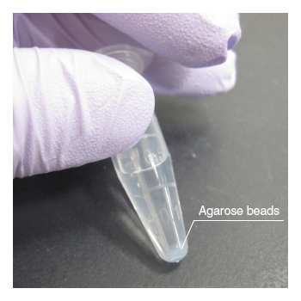
Incubate at 4°C for 1 hour-overnight on a rotating shaker.
Washing  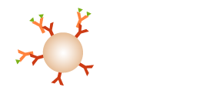  Pellet the agarose beads by centrifugation, and remove the supernatant by aspiration without disturbing the beads. | 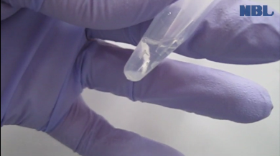
Add 1 mL of ice-cold lysis buffer or washing buffer, mix, and centrifuge. Remove the supernatant by aspiration without disturbing the beads. Repeat 3-4 times. | 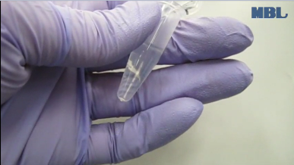
<When performing SDS-PAGE or Western blotting>  Add 50 µL of 2x SDS sample buffer containing 2-mercaptoethanol (2-ME) and heat for 5 minutes to elute the target protein from the beads. Centrifuge, and use the supernatant for SDS-PAGE.  ※The antibodies are co-eluted, which should be taken into account when analyzing the data. | 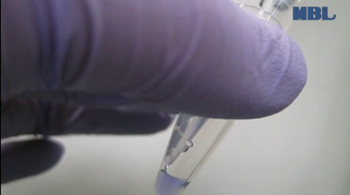
<When extracting the target protein while preserving its activity and native conformation (pull-down assay)>
Elute the target protein in neutral pH using an elution peptide and avoid harsh conditions, such as acidic and alkaline solutions.
[Related topics] Pull-down assay experiments using Tagged protein purification kits

Immunoprecipitation Technique

Immunoprecipitation (IP) is the small-scale affinity purification of antigens using a specific antibody that is immobilized to a solid support such as magnetic particles or agarose resin. Immunoprecipitation is one of the most widely used methods for isolation of proteins and other biomolecules from cell or tissue lysates for the purpose of subsequent detection by western blotting and other assay techniques.

What is immunoprecipitation? How does IP work?
Immunoprecipitation was first developed as an adaptation of traditional column affinity chromatography, which involves allowing sample, wash, and other solutions to pass through a column that is packed with porous resin (typically beaded agarose) onto which a target-specific antibody has been immobilized. However, instead of using a packed column, immunoprecipitation uses a small amount of resin in a microcentrifuge tube, and incubation steps are performed in a batch-wise manner. For each step, solution is added to the beads, which are then mixed and incubated together as a slurry (i.e., the beads are suspended in the solution). At the end of each incubation step, the beads are pelleted to the bottom of the tube by centrifugation (or a magnet; see below) so that the solution can be removed using a pipet.
Unlike column affinity chromatography, the goal of immunoprecipitation is to isolate just enough protein to be able to measure it by western blotting or other semi-quantitative or quantitative assay methods. Usually treated and untreated samples are compared to assess the relative amount of the protein of interest. The basic protocol for performing an IP is diagrammed below, where the order (sequence) of steps can be done in two different ways.
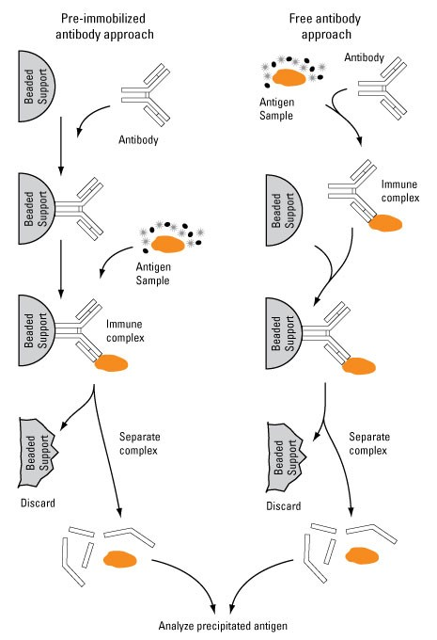
Diagram of immunoprecipitation (IP) using either pre-immobilized or free antibodies. Each step involves incubation, followed by bead collection (centrifugation or magnetic) and removal of the solution. Wash steps are also included after each incubation step. Elution during the final step typically involves heating the beads in sample loading buffer for polyacrylamide gel electrophoresis (SDS-PAGE), which results in denaturation of the proteins (including the antibody) and irreparable damage to the beads, which are discarded.
In one sequence (left), an antibody (monoclonal or polyclonal) against a specific protein is pre-immobilized onto an insoluble support, such as agarose or magnetic beads, and then incubated with a cell lysate containing the target protein. During the incubation period, gentle agitation of the lysate allows the target antigen to bind to the immobilized antibody. The immobilized immune complexes are then collected from the lysate, eluted from the support and analyzed based on the nature of the target antigen.
Alternatively (right), free, unbound antibody is allowed to form immune complexes in the lysate and the complexes are then retrieved by the beads. While the pre-immobilized antibody approach is more commonly used for IP, using free antibody to form immune complexes is beneficial if the target protein is present in low concentrations, the antibody has a weak binding affinity for the antigen or the binding kinetics of the antibody to the antigen are slow

Magnetic beads vs. agarose resin for immunoprecipitation
Because it developed as an adaptation of column affinity chromatography, the IP technique was first done using small aliquots (10–25 µL) of agarose resin in microcentrifuge tubes. Agarose beads are sponge-like structures of varying shapes and sizes (50 to 150 μm diameter). Centrifugation must be used to separate the beads from sample and buffer solutions, either by pelleting the translucent beads and carefully pipetting off the solution or by using a microcentrifuge filter cup to retain the beads and collect the solution in the tube upon centrifugation. These characteristics limit the extent to which agarose-based IP procedures can be scaled down or automated.
Magnetic particles, such as Dynabeads and Pierce magnetic beads, have largely replaced agarose beads as the preferred support for immunoprecipitation and other micro-scale affinity purification procedures. Magnetic particles are solid and spherical, and antibody binding is limited to the surface of each bead. While they do not have the advantage of a porous center to increase the binding capacity, magnetic beads are significantly smaller than agarose beads (1 to 4 μm diameter), which collectively give them sufficient surface area for high-capacity antibody binding.
High-power magnets are used to localize magnetic beads to the side of the incubation tube and out of the way to enable cell lysate aspiration without the risk of also aspirating immune complexes bound to the beads. Magnetic separation avoids centrifugation, which can break weak antibody-antigen binding and cause loss of target protein. They make it easier to manually pipet solutions from the beads, and instrumentation is available to fully automate magnetic bead procedures, even in 96-well microplate formats.
They make it easier to manually pipet solutions from the beads, and instrumentation is available to fully automate magnetic bead procedures, even in 96-well microplate formats.
The performance advantages of magnetic beads compared to agarose resin for immunoprecipitation procedures are summarized in the following table and described in detail thereafter. These advantages are supported by current publication trends (see summary of data here), which show a clear migration from resin-based to magnetic bead methods for IP.
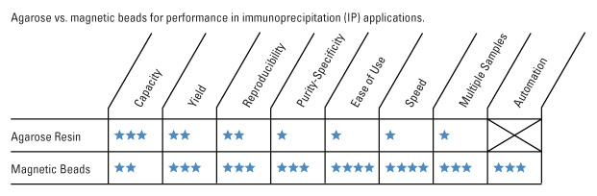
Performance of agarose resin vs magnetic beads in immunoprecipitation (IP) applications. This diagram compares and contrasts the distinct advantages and disadvantages of using agarose resin vs magnetic beads for immunoprecipitation.

Details concerning the advantages of magnetic beads for IP
Capacity and yield–Because beaded agarose resin is porous (sponge-like), it has a large surface-area-to-volume ratio and therefore a high binding capacity for antibody. Magnetic beads are nonporous with a smooth outer surface. Consequently, although they are much smaller than agarose beads, magnetic beads have a lower theoretical binding capacity than agarose. However, individual antibodies immobilized on the sponge-like agarose aren’t always accessible to target proteins (which often exist as large protein complexes) in a sample, and antibody may be lost during the washing steps (centrifugation). By contrast, antibodies bound to the surface of magnetic beads are all accessible to antigen, and the antibody is less likely to be lost during the gentle washing steps (on a magnet). Therefore, even if the antibody-binding capacity is lower compared to agarose, the final antigen yield is often the same or greater with magnetic beads.
Reproducibility and purity–With agarose beads, it is difficult to thoroughly remove buffer without also disturbing and drawing up some of the pelleted resin. With magnetic beads and a magnet, all the beads are held firmly to the side of the tube, so all of the buffer can be removed without touching the bead-pellet. Furthermore, agarose typically requires longer incubation times (to enable diffusion of solutions to the internal spaces within) and pre-clearing (to control non-specific bind of unwanted proteins). Because all interactions occur on the outer smooth surface of the magnetic beads, and because they are much more uniform in size, magnetic beads generally provide higher reproducibility and purity compared to agarose. Pre-clearing is usually not necessary with magnetic beads.
Ease of use, speed, and automation–Considered together, the aforementioned differences between agarose and magnetic beads explain why magnetic beads are now preferred for immunoprecipitation. Because it requires longer incubation times, pre-clearing steps, and several centrifugation steps, agarose-based IP requires considerable manual handling and a total time of 1–1.5 h to perform. By contrast, an individual magnetic bead IP experiment can be completed in about 30 min.
Furthermore, magnetic bead separation lends itself to processing multiple samples easily and rapidly. For example, with a DynaMagTM-2 Magnet and accompanying sample rack, one can easily process 16 samples at the same time using magnetic beads in microcentrifuge tubes. Also available is a magnet for 96-well plates. In fact, entire IP protocols can be automated with magnetic beads using small benchtop instrumentation, such the Thermo Scientific Kingfisher Flex Magnetic Bead Processor.

Summary of bead options for IP
Use magnetic beads for immunoprecipitation (i.e., when the sample size is < 2 mL). Magnetic beads provide the best balance of capacity/yield, reproducibility, purity, and cost savings for routine small-scale isolation of specific proteins and protein complexes. Magnetic beads are best for manual and automated standard IP, Co-IP, ChIP, ChIP-Seq, RIP, and pull-down reactions for immediate assay analysis.
Use agarose resin for protein purification (i.e., when the sample size is > 2 mL). Agarose is most appropriate for column affinity chromatography or individual, large-scale spin cup IP reactions when sufficient antibody is plentiful at a low cost and where the goal is to purify a sufficient amount of target protein for multiple downstream assays.

Types of immunoprecipitation
In its simplest form, IP is used to isolate a single protein (the target antigen of the antibody) to investigate its identity, structure, expression, activation or modification state. Variations of IP are also used to study the interactions of the primary antigen protein with other proteins or nucleic acids. In these methods, the goal is to study the interactors or associated cellular components that are bound to the primary antigen.
Co-immunoprecipitation is a popular technique for protein interaction discovery. Co-IP is conducted in essentially the same manner as an IP, except that the target antigen precipitated by the antibody is used to co-precipitate its binding partner(s) or associated protein complex from the lysate. The assumption that is usually made when associated proteins are co-precipitated is that these proteins are related to the function of the target antigen at the cellular level. This is only an assumption, however, that is subject to further verification.

Chromatin immunoprecipitation (ChIP) and RNA immunoprecipitation (RIP)
Chromatin immunoprecipitation (ChIP) assays are performed to identify regions of the genome with which DNA-binding proteins, such as transcription factors and histones, associate. In ChIP assays, proteins bound to DNA are temporarily crosslinked and the DNA is sheared prior to cell lysis. The target proteins are immunoprecipitated along with the crosslinked nucleotide sequences, and DNA is then removed and identified by PCR, sequenced, applied to microarrays or analyzed in some other way. RNA immunoprecipitation (RIP) is similar to ChIP, except that RNA-binding proteins are immunoprecipitated instead of DNA-binding proteins. Immunoprecipitated RNAs can then be identified by RT-PCR and cDNA sequencing.

A step-by-step guide to successful chromatin immunoprecipitation (ChIP) assays
This updated overview of the ChIP procedure includes additional detail about primary antibody selection (i.e., ChIP-validated antibodies). The application note also describes and provides examples of ChIP as a technique for studying epigenetics, as it allows researchers to capture a snapshot of specific protein-DNA.
Download A step-by-step guide to successful chromatin immunoprecipitation (ChIP) assays guide for an updated overview of this entire epigenetics technique from selection of ChIP-validated antibodies through cell lysis, optimization of chromatin digestion, bead choice, qPCR and more!

Tagged-protein IP or tag-based pull-down
A key limitation of the previously-described IP approaches is their dependence upon the availability of antibodies that specifically recognize the target protein with little or no cross-reactivity with other cellular targets. Due to this limitation, many proteins are unable to be immunoprecipitated because of the lack of an available antibody.
To circumvent this problem, proteins can be tagged with an epitope to which a high-affinity antibody is available and ectopically expressed in the cell of interest. Today, this approach is commonplace for all types of immunoprecipitations in molecular biology research. These tags can be either short peptide sequences or fluorescent proteins, including:
- FLAG; peptide sequence DYKDDDDK
- c-Myc; peptide sequence EQKLISEEDL
- Hemagglutinin (HA); peptide sequence YPYDVPDYA
- V5; peptide sequence GKPIPNPLLGLDST
- Green fluorescent protein (GFP)
One downside of using tagged proteins is that the overexpressed tagged protein, not the endogenous protein, is immunoprecipitated, which limits the applicability of any findings using this approach to true biological relevance. Additionally, tagging the protein may interfere with protein function.
However, growth factors and conditions affecting a specific protein-protein interaction in cultured cells can be measured very precisely using a quantitative immunoprecipitation (qIP) method based on co-expression of epitope-tagged and luciferase-tagged proteins.

Strategies for antibody immobilization

Antibody-binding proteins
Protein A, Protein G, Protein A/G and Protein L are immunoglobulin (Ig)-binding proteins that, when attached to beaded support and used as affinity ligands, comprise the most popular antibody-binding platforms for IP applications. As shown in the diagram below, Proteins A and G both show specificity for the heavy chains on the Fc region of antibodies, which effectively orients the immobilized antibodies with antigen-binding sites facing outward; Protein G also shows some affinity for Fab fragments (1,3). Protein L binds to light chains, but because of specific binding characteristics, Protein L is only used for limited applications.
Most immunoprecipitations are performed with Protein A, Protein G or Protein A/G, which is an engineered recombinant protein combining four Protein A and two Protein G antibody binding sites. Protein A and G both show high affinity for antibodies of multiple, but not necessarily identical, subclasses and Ig species, while Protein A/G binds all of the subtypes to which Protein A and G individually bind.
Immobilized Protein A, G and A/G (hereafter collectively called "Protein A/G") are effective tools for attaching antibodies to a beaded support for IP applications. Innovations in manufacturing of prepared Protein A/G resins and beads have yielded commercially available supports that have very high binding capacities, enabling excellent immunoprecipitation results to be obtained with very small volumes of beads.
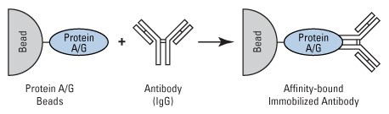Diagram of Protein A/G-mediated antibody immobilization to beaded support. Protein A/G (or Protein A or Protein G) binds to the Fc region of an IP antibody to immobilize it in the correct orientation to immunoprecipitate the target antigen.
Specificity of antibody-binding proteins. Proteins used to immobilize antibodies to beaded support show specificity to different antibody domains. Protein A and G bind to the heavy chains of the antibody Fc region, while Protein L specifically binds the light chains of the two Fab regions of the F(ab')2antibody fragment.
Protein A/G supports are not compatible with certain IP experimental situations, such as when an incompatible antibody species or subclass is used or when immunoprecipitating from serum, which contains nonspecific immunoglobulins that would compete with the IP antibody for binding to the support.

Streptavidin beads with biotinylated antibodies
`````
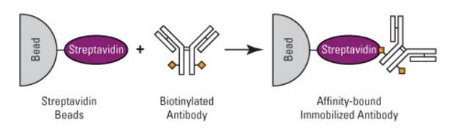
Diagram for using biotinylated antibodies and streptavidin-coupled beads to perform immunoprecipitation. This strategy can be used for classes of IP antibodies that do not bind well to Protein A or G. The strategy is also effective for pull-down reactions with any sort of biotinylated molecule

Covalent antibody immobilization
Covalent immobilization strategies chemically bind the antibody to the beaded support and remove the requirement for Protein A/G-dependent antibody immobilization. Commercial products are available that provide beaded supports that react with primary amines (-NH2) on the antibody to permanently bind the antibody to the support. Although this method couples antibodies in random orientation (based on whichever surface amines contact the reactive groups on the beads), this usually has only slight effects on the antigen-binding function and capacity of the IP antibody. Besides eliminating the dependence on Protein A/G, the direct immunoprecipitation method prevents the IP antibody from co-eluting with the antigen (when a non-reducing elution buffer is used) and interfering in SDS-PAGE analysis. Additionally, because the antibody theoretically remains intact and permanently bound to the support, it may be possible to reuse the antibody-coated support many times.
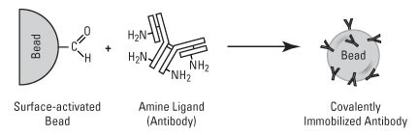Schematic representation of a direct method to covalently immobilize antibody to IP support. This diagram features aldehyde-activated agarose beads (AminoLink Resin), but a similar immobilization mechanism applies to epoxy-activated Dynabeads and other magnetic beads.

Crosslinking antibody immobilization
It is also possible to covalently attach antibodies to Protein A/G-bound supports using a crosslinker. Examples of such crosslinkers include DSS and BS3, which are short carbon chains with reactive N-Hydroxysuccinimidyl (NHS) ester groups at each end. NHS esters react with primary amines (side chain of lysine residues in proteins) to form covalent amide bonds. If an antibody is first bound to a Protein A/G support and then mixed with a crosslinker solution, the crosslinker molecules can react to covalently link adjacent amines of the antibody and Protein A/G.

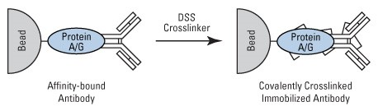
Schematic representation of covalently crosslinking the antibody to Protein A/G-coated beaded support. This diagram features agarose beads, but the same immobilization mechanism applies to Dynabeads and other magnetic beads.
As with the direct immobilization method, the crosslink method eliminates co-elution of antibody fragments and potentially enables the antibody support to be reused several times. For obvious reasons, this method can only be used for antibodies that successfully bind to Protein A or G. Because antibodies contain multiple amine groups that are not exclusively limited to the Fc region, it is important to optimize the dosage of crosslinker. If too little or too much crosslinker is used, the antibody may not become successfully linked to the Protein A/G agarose or too many of the amine groups in the antibody binding site may become modified, rendering the antibody unable to bind antigen.

IP buffers and optimization

Lysis Buffers
Although IP methods are logically and procedurally simple, the variables affecting the success of any specific experiment are as numerous and peculiar as the specific differences between individual proteins and different primary antibodies. Empirical testing is nearly always required to optimize IP conditions to obtain the desired yield and purity of target proteins. Nevertheless, consideration of the main factors involved can help to identify the components that are most likely to affect particular experiments. e control for an IP or co-IP experiment; any products obtained with these control conditions can be attributed to nonspecific (off-target) interactions. One advantage of the direct immobilization strategy described above is the lack of Protein A/G as a component, which is a potential source of nonspecific binding interactions in the assay system.
The quality of the sample that is used for IP applications critically depends on the right lysis buffer, which stabilizes native protein conformation, inhibits enzymatic activity, minimizes antibody binding site denaturation and maximizes the release of proteins from the cells or tissue. The lysis buffer used for a particular application depends on the target proteins that will be immunoprecipitated, because the location of the protein in the cell (e.g., membrane, cytosol, nucleus) affects the ease of release during lysis.
Non-denaturing buffers are used when the IP antigen is detergent-soluble and when the antibody can recognize the native form of the protein. These buffers contain non-ionic detergents, such as NP-40 or Triton X-100. Denaturing buffers, such as radio-immunoprecipitation assay (RIPA) buffer, are more stringent than non-denaturing buffers because of the addition of ionic detergents like SDS or sodium deoxycholate. While these buffers do not maintain native protein conformation, proteins that are difficult to release with non-denaturing buffers, such as nuclear proteins, can be released with denaturing buffers. Both buffers contain NaCl and Tris-HCl and have a slightly basic pH (7.4 to 8). Detergent-free buffers can also be used if the target protein can be released from cells using only physical disruption, such as mechanical homogenization or heat. These simple buffers usually consist of just EDTA in phosphate buffered saline (PBS). See the table below for the ranges of each component to aid in protocol optimization.
Because cell lysates also contain proteases and phosphatases that can modify or degrade the target protein, most IP protocols are performed at 4°C. Proteasomal inhibitors, such as PMSF, aprotinin and leupeptin are commonly added to the lysis buffer just prior to use, along with sodium orthovanadate or sodium fluoride as a phosphatase inhibitor. While these components can be added individually, commercial inhibitor cocktails are available that are higher quality and easier to use.
IP buffer component concentration ranges for optimization (2).
Component | Range
Non-ionic detergents (NP-40, Triton X-100) | 0.1 to 2%
Ionic detergents (SDS, sodium deoxycholate) | 0.01 to 0.5%
NaCl (sodium chloride, salt) | 0 to 1M
Divalent cations | 0 to 10mM
pH | 6 to 9
EDTA | 0 to 5mM

Sample preclearing (optional for magnetic beads)
Because lysates are complex mixtures of proteins, lipids, carbohydrates and nucleic acids, one must generally assume that some amount of nonspecific binding to the IP antibody, Protein A/G, or the beaded support might occur and negatively affect the detection of the immunoprecipitated target(s).
Preclearing is designed to remove potentially reactive, non-specific components from a lysate sample prior to the actual immunoprecipitation procedure. Preclearing is frequently necessary when using agarose beads, but it is seldom required when using magnetic beads (see videos below).
The basic approach to preclear a lysate is to incubate the sample with exactly the same components that will be used for the immunoprecipitation, except use a nonspecific antibody from the same host species as the IP antibody. Any nonspecific immune complexes will form and be immobilized to the beaded support. Additionally, if Protein A/G or agarose beads are used, this approach will allow nonspecific binding to these IP components, which along with the nonspecific immune complexes are removed from the lysate. If successful, the nonspecific lysate products will be removed by this preclearing step so that they will not co-purify with the target antigen in the actual IP experiment.
These nonspecific immune complexes may be used as a negative control for an IP or co-IP experiment; any products obtained with these control conditions can be attributed to nonspecific (off-target) interactions. One advantage of the direct immobilization strategy described above is that it is devoid of Protein A/G as a component, thereby eliminating one potential source of nonspecific binding interactions in the assay system.

Binding and wash buffers
During the immunoprecipitation, assembling the immune complexes and maintaining complex stability depend on the compatibility of the binding buffer with all of the component binding interactions. In most cases, antibody-antigen interactions are fairly robust and will occur in any standard ionic strength buffer of near-neutral pH, such as PBS. By contrast, bait-prey interactions range in strength and time from irreversible and long-lived to labile and transient, which will be influenced by both the binding conditions and the temporal completion of protocol steps.
Even after lysate preclearing, IP components will still pull down nonspecific cellular components that must be removed by gentle washes prior to sample elution. Multiple washes with simple wash buffers, such as PBS either alone or with low detergent concentrations or by moderate adjustments to salt concentration, can be used to remove these contaminants.

Elution buffers
Traditional IP for downstream analysis by reducing SDS-PAGE and western blot detection typically involves elution directly in reducing SDS-PAGE sample buffer. This buffer, which is designed to denature and reduce proteins for electrophoresis, is very effective in dissociating the affinity interactions upon which IP is based. Other downstream applications for IP products are not compatible with this buffer system, nor is it possible to take advantage of certain IP methods, such as antigen elution, without antibody fragment contamination in the direct or crosslink IP methods, when this elution buffer condition is used.
The most generally effective, nondenaturing elution buffer for protein affinity purification methods is 0.1 M glycine at pH 2.5 to 3. The low pH condition dissociates most antibody-antigen interactions, as well as the antibody-Protein A/G interaction, assuming that it has not been crosslinked. However, low-pH glycine is not universally effective; some antibody-antigen interactions do not dissociate with this buffer, and conversely, some antibodies and target antigens denature or become inactive in this buffer. Several alternative types of elution buffers are described in the following documents.

References
- Bjorck L. and Kronvall G. (1984) Purification and some properties of streptococcal protein g, a novel IgG-binding reagent. J Immunol. 133, 969-74.
- Harlow, Ed, and Lane, David. (1999) Antibodies: A Laboratory Manual. Cold Spring Harbor, New York: Cold Spring Harbor Laboratory Press.
- Wikstrom M. et al. (1995) Mapping of the immunoglobulin light chain-binding site of protein l. J Mol Biol. 250, 128-33.

